**Student Information**

* **Name:- Aditya Kumar**
* **Sap Id :- 590015145**
* **Branch :- M.C.A**
* **Batch :- B1**
* **Instructor:- Dr. Sourbh Kumar**
* **Subject :- Data Structures lab**

**Lab Assignment 1: Basic Array Operations**

**#include <stdio.h>**

***void* findLargestSmallest(*int* *arr*[], *int* *n*, *int* \**largest*, *int* \**smallest*)**

**{**

**\**largest* = *arr*[0];**

**\**smallest* = *arr*[0];**

**for (*int* i = 1; i < *n*; i++)**

**{**

**if (*arr*[i] > \**largest*)**

**{**

**\**largest* = *arr*[i];**

**}**

**if (*arr*[i] < \**smallest*)**

**{**

**\**smallest* = *arr*[i];**

**}**

**}**

**}**

***void* sortArray(*int* *arr*[], *int* *n*)**

**{**

**for (*int* i = 0; i < *n* - 1; i++)**

**{**

**for (*int* j = 0; j < *n* - i - 1; j++)**

**{**

**if (*arr*[j] > *arr*[j + 1])**

**{**

***int* temp = *arr*[j];**

***arr*[j] = *arr*[j + 1];**

***arr*[j + 1] = temp;**

**}**

**}**

**}**

**}**

***int* main()**

**{**

***int* n;**

**printf("Enter the number of elements: ");**

**scanf("%d", &n);**

***int* arr[n];**

**printf("Enter %d elements:\n", n);**

**for (*int* i = 0; i < n; i++)**

**{**

**scanf("%d", &arr[i]);**

**}**

***int* largest, smallest;**

**findLargestSmallest(arr, n, &largest, &smallest);**

**printf("Largest element: %d\n", largest);**

**printf("Smallest element: %d\n", smallest);**

**// Corrected function call to include the size of the array**

**sortArray(arr, n);**

**printf("Sorted array: ");**

**for (*int* i = 0; i < n; i++)**

**{**

**printf("%d ", arr[i]);**

**}**

**printf("\n");**

***int* sum = 0;**

**for (*int* i = 0; i < n; i++)**

**{**

**sum += arr[i];**

**}**

***float* average = (*float*)sum / n;**

**printf("Sum of elements: %d\n", sum);**

**printf("Average of elements: %.2f\n", average);**

**return 0;**

**}**

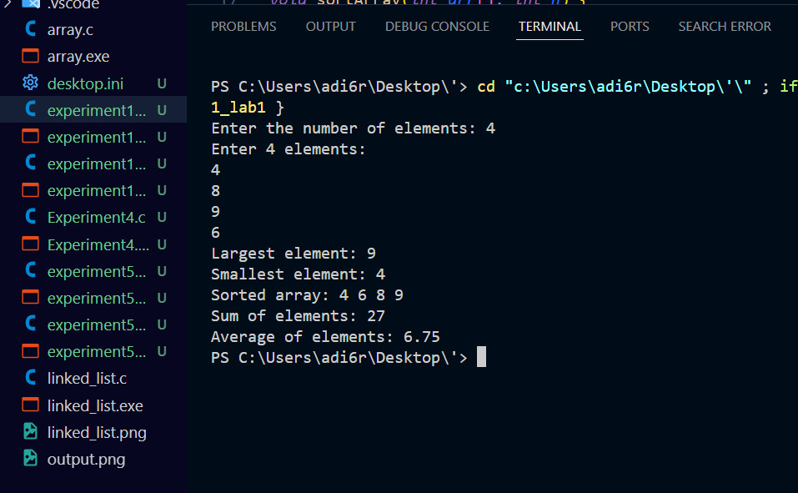

**Lab Assignment 2: Array of Structures**

**#include <stdio.h>**

**#include <string.h>**

***struct* Student {**

***char* name[50];**

***int* age;**

***int* marks;**

**};**

***void* inputDetails(*struct* Student *students*[], *int* *n*) {**

**for (*int* i = 0; i < *n*; i++) {**

**printf("Enter details for student %d:\n", i + 1);**

**printf("Name: ");**

**scanf("%s", *students*[i].name);**

**printf("Age: ");**

**scanf("%d", &*students*[i].age);**

**printf("Marks: ");**

**scanf("%d", &*students*[i].marks);**

**}**

**}**

***void* displayDetails(*struct* Student *students*[], *int* *n*) {**

**printf("\nStudent Details:\n");**

**for (*int* i = 0; i < *n*; i++) {**

**printf("Name: %s\n", *students*[i].name);**

**printf("Age: %d\n", *students*[i].age); // Corrected this line**

**printf("Marks: %d\n\n", *students*[i].marks);**

**}**

**}**

***void* sortStudents(*struct* Student *students*[], *int* *n*) {**

**for (*int* i = 0; i < *n* - 1; i++) {**

**for (*int* j = 0; j < *n* - i - 1; j++) {**

**if (*students*[j].marks < *students*[j + 1].marks) {**

***struct* Student temp = *students*[j];**

***students*[j] = *students*[j + 1];**

***students*[j + 1] = temp;**

**}**

**}**

**}**

**}**

***struct* Student findTopStudent(*struct* Student *students*[], *int* *n*) {**

***struct* Student topStudent = *students*[0];**

**for (*int* i = 1; i < *n*; i++) {**

**if (*students*[i].marks > topStudent.marks) {**

**topStudent = *students*[i];**

**}**

**}**

**return topStudent;**

**}**

***int* main() {**

***int* n;**

**printf("Enter the number of students: ");**

**scanf("%d", &n);**

***struct* Student students[n];**

**inputDetails(students, n);**

**displayDetails(students, n);**

**sortStudents(students, n);**

**printf("\nStudents sorted by marks (descending order):\n");**

**displayDetails(students, n);**

***struct* Student topStudent = findTopStudent(students, n);**

**printf("\nTop Student:\n");**

**printf("Name: %s\n", topStudent.name);**

**printf("Age: %d\n", topStudent.age);**

**printf("Marks: %d\n", topStudent.marks);**

**return 0;**

**}**

